Practical 2: Mathematical tools for Image Processing
2(A) Arithmetic operations on digital images
Aim: To understand practical implementation of Arithmetic operations on digital images
Software Used: Jupyter Notebook
Theory: Arithmetic operations on digital images involve performing basic mathematical operations such as addition, subtraction, multiplication, and division on image pixel values. These operations are usually applied pixel by pixel between two images or between an image and a constant. Image addition is commonly used for brightness enhancement and noise reduction by averaging multiple images.
Subtraction helps in detecting changes between images, such as in motion detection and medical imaging. Multiplication and division are used for contrast adjustment and image normalization. These operations require images to be of the same size and data type. Proper scaling or normalization is necessary to avoid overflow or underflow of pixel values. Arithmetic image processing plays an important role in image enhancement, analysis, and computer vision applications.
Implementation & Result:
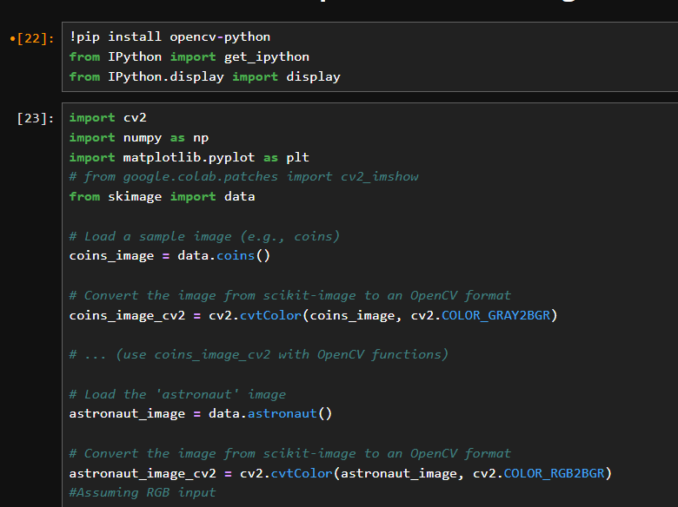
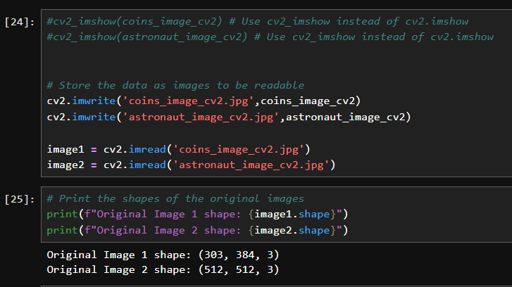
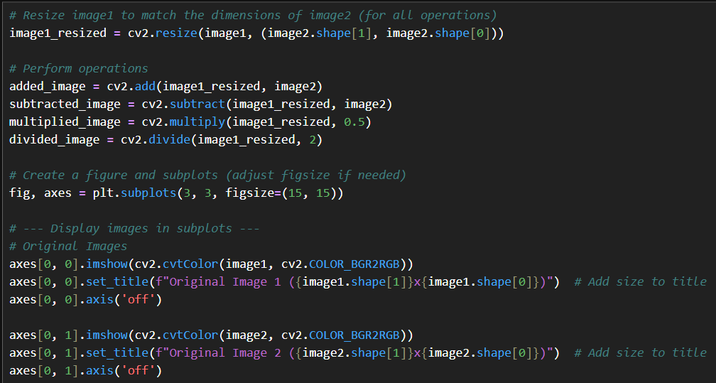
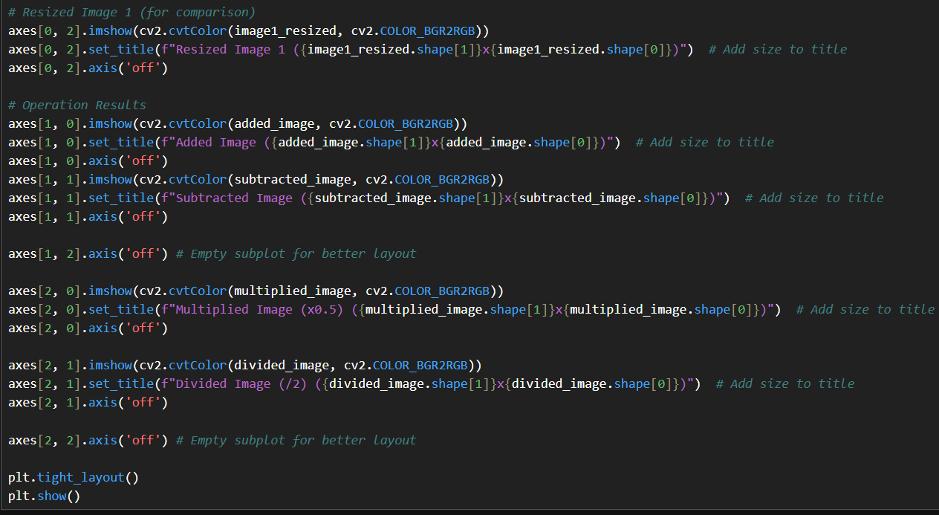
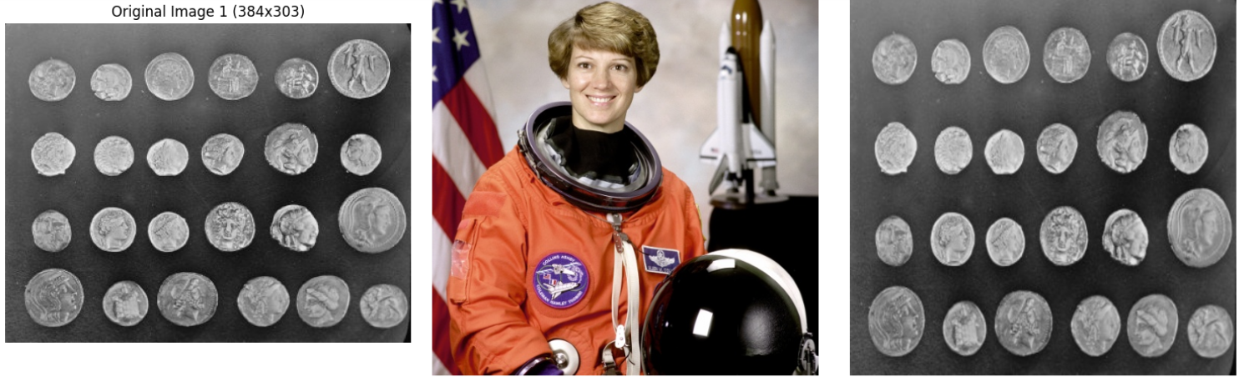
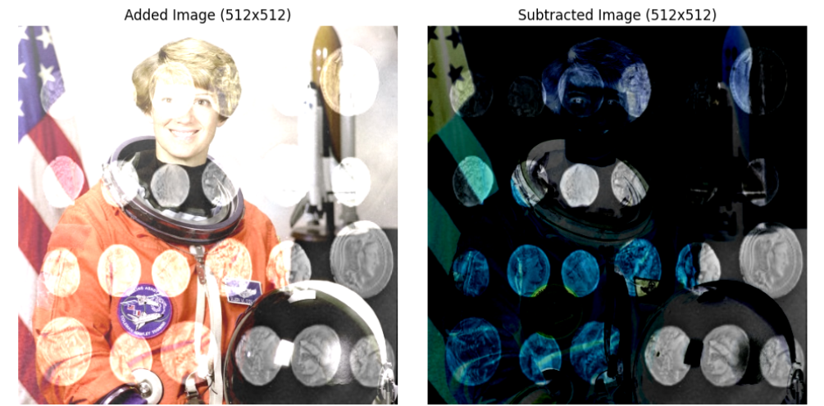
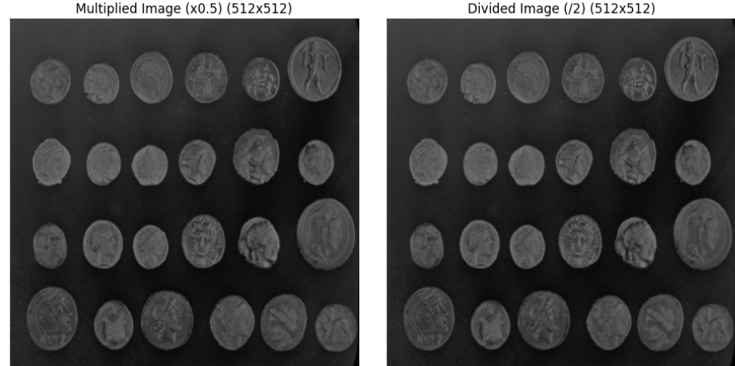

Conclusion: In conclusion, arithmetic operations on digital images involve performing mathematical calculations on pixel values to modify and enhance image characteristics. These operations help in tasks such as image enhancement, change detection, contrast adjustment, and noise reduction. By applying arithmetic techniques, digital images can be effectively analyzed and processed, making them a fundamental part of image processing and computer vision applications.

1B) Discrete Cosine Transformation.
Aim: To study and implement the Discrete Cosine Transform (DCT) for analyzing and transforming digital images into the frequency domain.
Software Used: Jupyter Notebook
Theory: The Discrete Cosine Transform (DCT) is a mathematical technique used to convert a digital image from the spatial domain to the frequency domain. It represents the image as a sum of cosine functions with different frequencies and amplitudes. The DCT concentrates most of the important visual information into a few low-frequency components, making it very effective for image compression.
High-frequency components represent fine details and edges, while low-frequency components represent smooth areas of the image. Because of this energy compaction property, DCT is widely used in image processing applications such as JPEG image compression and feature extraction.
Implementation & Result:
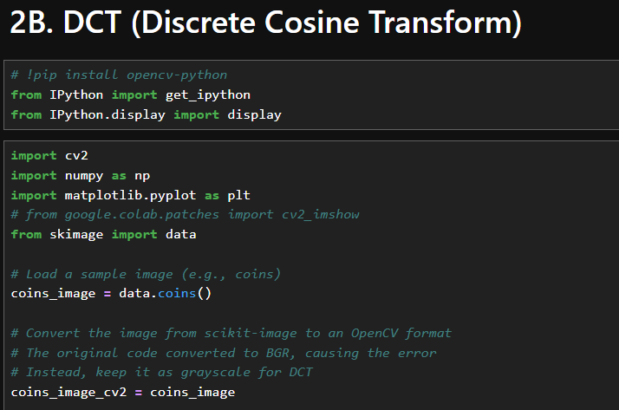
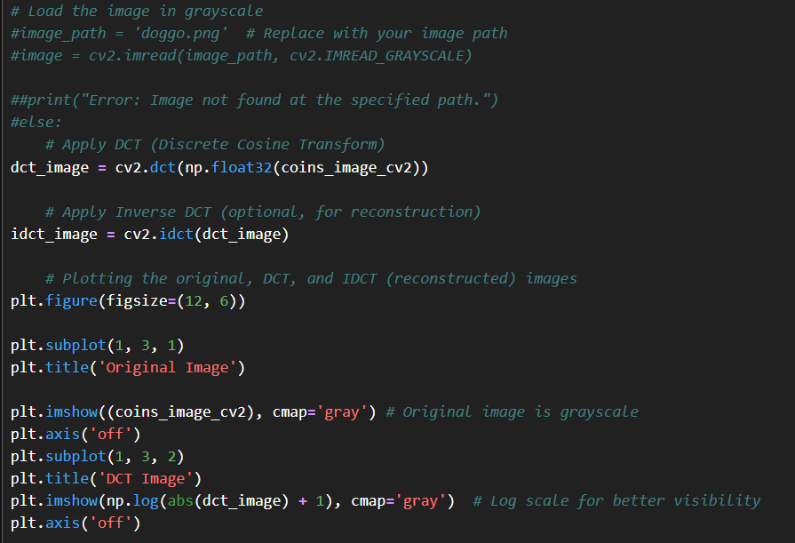
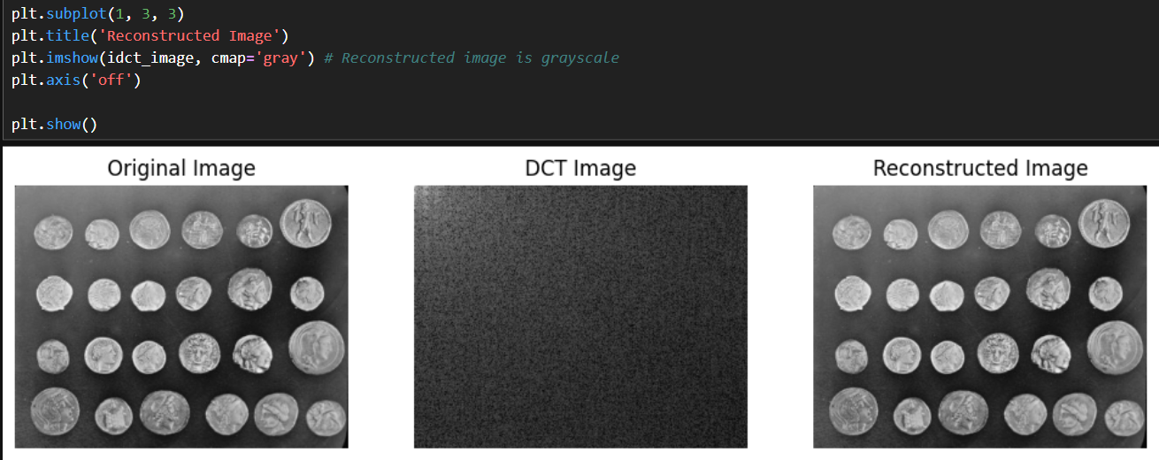

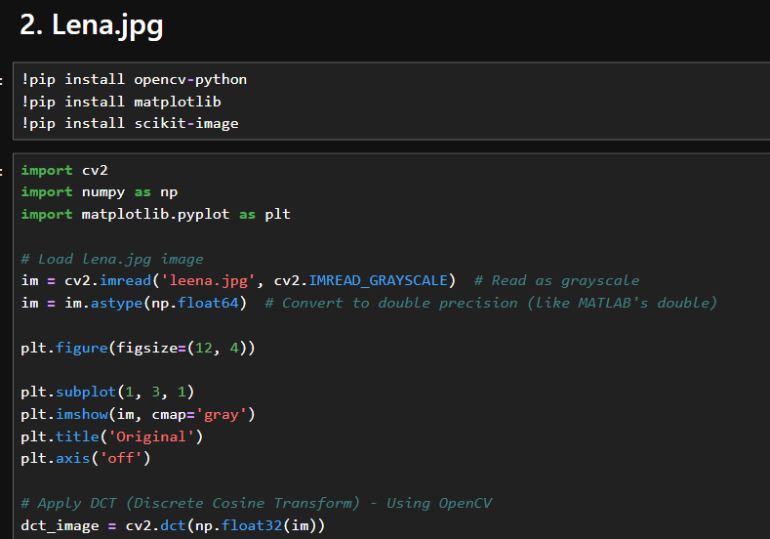
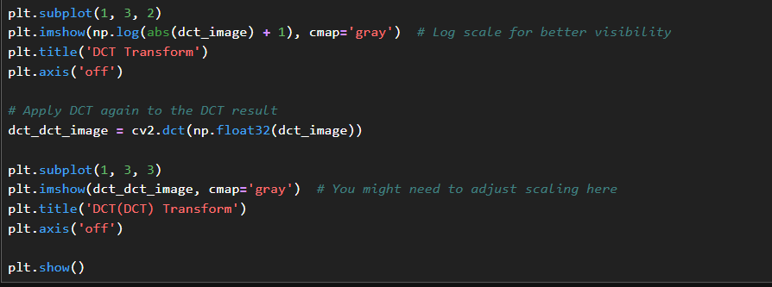
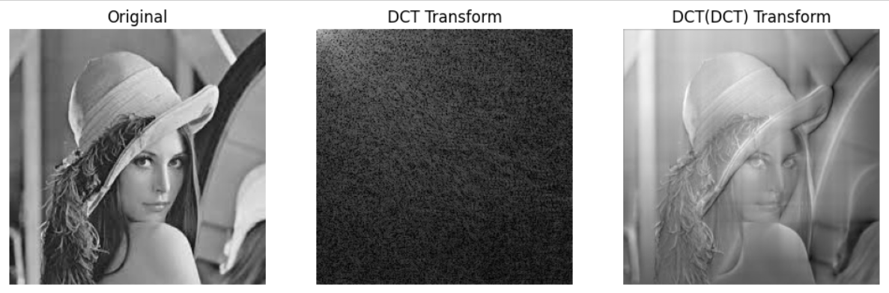

Conclusion:
In conclusion, the Discrete Cosine Transformation (DCT) is an important technique in digital image processing that converts spatial domain image data into frequency domain components. It helps in separating significant visual information from less important details, making it highly effective for image compression, noise reduction, and feature extraction. By concentrating most of the image energy into a few low-frequency coefficients, DCT reduces data redundancy and improves storage and transmission efficiency. Therefore, DCT plays a fundamental role in various applications such as image compression standards (like JPEG) and other computer vision and multimedia processing systems.

